

Name : Tan Yng Chun

Login ID : tanyngchun@oasis-portal.com

Course title : Executive Diploma in Culinary Arts & Hospitality Management

Subject Code : CA03 International Cuisine

Submitted date: **7th/September/ 2017**

**Table of Contents**

|  |  |  |
| --- | --- | --- |
| **No** | **Details** | **Page** |
| 1 | Executive Summary | P2 |
| 2 | Introduction | P3 |
| 3 | Assignment Question |  |
|  | Part 1 | P4-P6 |
|  | Part 2 | P7-P11 |
|  | Part 3 | P12-P15 |
|  |  |  |
| 4 | Conclusion | P16 |
| 5 | References | P17 |
|  | Appendix |  |

**Executive Summary**

In this assignment, we will learn about the purpose of this unit that is to be able to understand International Cuisine within Culinary Arts and Hospitality Management.

We will learn to choose one dish from each cuisine. The cuisines are Chinese, Indian, and Western cuisine. From each cuisine, we will need to recreate or alter the original recipe into our own recipe.

From the assignment, we learn about the food is complicated but can be simple. We do the best preparation from freshly ingredients and cook a great dish with time, energy, and heart thinking about the guests for serves them with a palatable dish. For someone who is working at Food and Beverages must be always thinking about what guests thinking.

**Introduction**

International cuisine means global cuisine. Cuisine is a style or manner of cooking which a form of coalesce characteristics of a culture, region, and a country. Actually if we research more deeply, it cans diversity to climate, ethnic groups and religion.

Chinese cuisine history started at 2200 to 3800 years ago. In the 11th century BCE (Before Common Era), China knew as a Middle Kingdom, people of small communities lived in Beijing and Yellow River delta, follow the climate, from fifth to third century, seafood occurs at east, animal hunted at west and north.

“The period of five grains/cereals” is known because food eated by China’s people in ancient times is true cereal grains, true whole grains comes from the grass family, that is gramineae, it includes wheat, oats, rice and wild rice, soybeans, barley, foxtail millet and teff (teff is a type of millet), broomcorn (corn is known as “maize”), rye and triticale (triticale is mixture of wheat and rye), the pseudo-cereal grains is amaranth, buckwheat, and quinoa (pronounced as “keen-wah”), pseudo-cereal grains is not a part of poaceae botanical, it not from the grass family, we called it as “ancient-grains” , cereal grains and pseudo-cereal \grains both is staple crop of starchy.

**Assignment Questions**

**I. Chinese Cuisine**

Chinese is a country which had a word “hunger breeds is discontentment”. It mean the food is most important to people, people regard food as their essential for life and food should be the first thing necessity to people.

In Chinese, there is “Eight Cuisines”. For the Eight Cuisines, we have three traditional aspects to describe it; it should be color, smell and taste.

Eight Cuisines:

* Anhui
* Cantonese
* Fujian
* Hunan
* Jiangsu
* Shandong
* Szechuan
* Zhejiang

**My own recipe for Simply Egg Fried Rice:**

Preparation Time: 15 minutes

Cooking Time: 20 minutes

Total Time: 35 minutes

**Ingredients:**

Sesame oil (vegetable, olive oil, optional)

2 tablespoon chopped garlic

1 tablespoon ginger paste

5 big-sized eggs

2 tablespoons chopped spring onion

6 tablespoons sliced white onion

2 teaspoons crushed pepper

2 teaspoons salt

2 tablespoons Hua Diao Chiew

**Methods:**

1. Stir rice with a wooden ladle till it enough softener. Wait for the wok or hot pan enough hot, put the sesame oil and no need to waiting for hot, just add chopped garlic, sliced white onion and ginger paste, and fry till smell is come out.

2. Add 3 eggs which is already break in a mixing bowl and add rice when still liquid state. Fry the rice and add another 2 eggs, keep frying till the rice become golden color.

3. Add spring onion, salt and crushed pepper, tasted and add Hua Diao Chiew for upgrade the flavor.

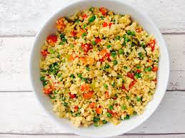

Figure for Egg Fried Rice

**II. Indian Cuisine**

In people’s knowledge, an Indian food always be spicy, but actually in Indian food, mostly of them are consisted diet of legumes, vegetables, fruits, grains, dairy products, and whole-wheat flour.

**My own recipe for curry fish (Meen Kulambu) from South Indian Cuisine:**

Preparation Time: 1 hours and 15 minutes

Cooking Time: 15 minutes

Total Time: 1 hours and 30 minutes

**Ingredients:**

1-inch thick piece of sardine fish (you can choose from rainbow trout, tilapia, tuna, or Pollock)

8 dry red chilies

2 cups of tamarind (soak in hot water)

2 tablespoons coriander powder

1 tablespoon turmeric powder

1 tablespoon paprika powder

2 cups coconut milk

1 tablespoon salt

2 teaspoons crushed black pepper

3 tablespoons coconut oil (vegetable, canola, olive, sunflower, rapeseed oil, optional)

1 teaspoon fenugreek seed

1 big-sized sliced onion

1 tablespoon chopped garlic

8 to 10 curry leaves

1 of 2 teaspoon cumin powder (increase sweet taste)

Parsley, Cilantro for garnish (optional)

**Methods:**

1. Use a mortar and pestle to make the dry chilies into ground paste. Squeeze the soaked tamarind and discard the pith and seeds, left behind the juice only.

2. Mix the red chilies paste and tamarind juice and add the coriander powder, paprika powder and turmeric powder, add salt to taste. Add the coconut grated and half the coconut milk, mix well.

4. Pour the mixture above sardine, use a spatula to make sure the surface of sardine is coated. Marinate for 1 hour.

5. Use a skillet to fry the curry leaves and fenugreek seeds with high heat, till it splutters. Turn the heat to moderate heat then add the half of sliced onion and fry it till become brown color.

6. Add marinade of fish and tomato paste to stir, add another half of sliced onion, crushed black pepper, cumin powder and remaining coconut milk for lifting it sweet taste.

7. Stir till the oil appears on top of gravy, add the piece of sardine fish, and stir by a wooden ladle so the sardines will no break easily.

Tips:

Curry fish can serve with plain rice, dosa (a type of pancake) and idli (a kind of savory cake).

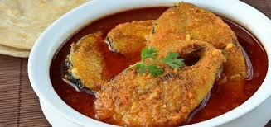

Curry Fish from South Indian Cuisine

Indian cuisine it has several parts, it is:

1. North Indian Cuisine

North-Indian cuisine was affected by Middle Eastern and Central Asian. Its geographical position let it affected in both culture and foods. It includes states like Punjab, Sindh, Delhi, Haryana, Jammu and Kashmir, Himachal Pradesh, Uttar Pradesh, and Uttarakhand. Curries in North Indian can separately to spicy, moderately spicy and creamy gravies. It always meat combine with bread and it use dairy products like milk, cream, cottage cheese, ghee (clarified butter, originated from Indian subcontinent), and yogurt in many dishes. Dishes of North Indian like naan bread, rotis, and samosas, curries had palak paneer (spinach and cheese), aloo ghobi (potatao and cauliflower). Food of North Indian is usually served with nuts.

1. South Indian Cuisine

South Indian includes states like Andhra Pradesh, Kerala, Tamil Nadu, Telangana, and Karnataka. Its location is near coastline and it got the rice-based dishes. Sauces for rice know as Sambal/Sambar and Rasam as a spicy soup in South Indian. Sambal we know as another name such as huli, Rasam we also know for as saaru, chaaru or kabir. Famous food of South Indian is Idli, dosas, Sambhar, and Vada. For South Indian and North Indian, there same food such as raita, a kind of yogurt (dahi) based dishes, it usually made as a coolant for neutralized hot and spicy food.

1. Andaman and Nicobar Islands

In the Island, it is affected and influenced by the other culture, religions and regions. Andamanese, Jarawas, and Sentinelis is tribal community in the island. For availability of coconut and spices, the most of the dishes is use same ingredients for example tempered with oil at final of cooking, mustard seeds, curry leaves, red chilies, and Ural dhal. No matter is vegetarian or non-vegetarians in South-Indian. During research, we can find out culture of Andaman and Nicobar Islands are similar to Indian culture, which makes reflecting in their food culture. They are serving sea food as a main dish, a major of Andaman and Nicobar cuisine also is a paradise to seafood lovers. Some famous dishes like tandoori fish, khadi crabs, tiger prawns, red snappers; even turtle egg is value and worthy for it.

1. Andhra Pradesh

Andhra Pradesh is a state located in South Indian, it always heavy rainfall because after summer, monsoon is soon coming, monsoon let the tropical fruits and vegetables grow healthily. It also had the seafood such as pomfret, seabass, haemulon, and ribbon fish. Andhra Pradesh is Pulihora/Tamarind rice with green chilies, South Indian food is always hot and spicy, Andhra Pradesh maybe the hottest and spicy cuisine in all Indian cuisines. Most of spices, know as Indian masala, masala is a name of spice, difference masala have different aroma, taste, color, flavor, and pungency. In Andhra Pradesh, mostly curries like Gutti Vankaya Kura/Brinjal Curry have inside vegetables ingredient for balanced diet.

Types of masala:

* Garam Masala
* Tandoori Masala
* Tikka Masala
* Chai Masala
* Curry powder

Cuisine of Andhra Pradesh knows as a fusion of original Andhra ingredient and Hyderabad cuisine. Hyderabad is de jure capital of Andhra Pradesh and Telangana, Hyderabad cuisine like Andhra Pradesh cuisine, it influenced by Mughlai, Mughlai is pronounced “moog-lie”, it from 1426 to 1857, the food is cooked with dried fruits, nuts, and aromatic spices. Mughlai is a cooking style we can found in Delhi and Uttar Pradesh, common dishes is kebabs, kofta (meatballs), pulao (pilaf), and biryani.

1. Arunachal Pradesh

For Arunachal Pradesh cuisine, not like other cuisine, find different food from region to region, the food is different from tribe to tribe, because there is 26 major tribes and over 100 sub-tribes, basically we know eastern side is eating the bamboo and leafy vegetables which are boiled thoroughly, western side is mostly use dairy product in their cooking food. But there are something is same in Arunachal Pradesh, the staple food always is rice, and rice wrapped with a long leaf, long leaf is called tong by Tai Khampti people and the other tribes is called ekkam. In Northeast, fish which is blended with local herbs can wrapped with tong/ekkam and steamed, we called paa nung, different ingredients such as boiled bamboo shoot first and flavoured with ginger leaves for vegetarians. Back to the opening, to Arunachal Pradesh, rice is the staple food, it compare with meat, fish, and vegetables. We got two ways for preparing the rice, the first way is Dung Po, about Dung Po, we cannot find out not more about it, the second way is Surti Kolam/Surati Kolam, Surati Kolam is a medium-size rice grain, and it is firm from outside when uncooked and take out the smells from inside when it is cooked. It is rich in nutrition and has a long shelf life.

1. Assam

Assam is a place surround by lush forests and paddy field that are spread over around 800kms. Assamese cuisine is less spicy, less oil and richness in taste and healthy. But people normally will use herbs to strong the impact of foods. Food culture of Assamese cuisine is influenced by Southeast Asian. Several type of rice like Cheera/Spinach (flattened rice, cooked with chopped spinach), muri (puffed rice, made from a type of puffed grain), akhoi (parched paddy grain), pithguri (pound rice), sandoh guri (fried, pound rice) that we known. Assamese cuisine serving vegetable dishes in bell metal utensils they called Kahor Thal.

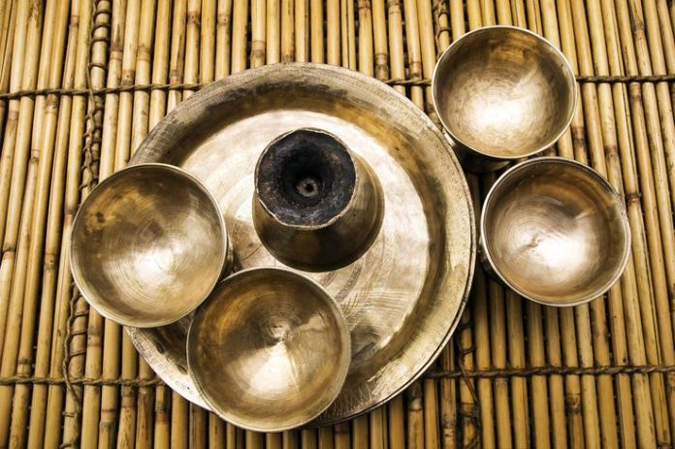

Figure for Bell metal Utensils

7. Delhi

Delhi is a union territory in Northern India, food in Delhi normally known as a mouth-washing dishes, because not just in the restaurants or hotel, Delhi cuisine is always use traditional cooking method and knew by people as a local cuisine, we can find snack such as momos, rolls, golgappas, paranthe and rajma chawal at roadside, there is always some vendors selling the food. In Delhi cuisine, commonly food know as Chole Bhature, a dishes accompanied by lassi, lassi is a yogurt-based drink, a savoury drink for food which are spicy, rich and heavy taste. For start a new day, Nihari is an appropriate choice for labourers, coolies, and rickshaw pullers; because the broth of mutton, chicken or beef, they are usually use a slow cooking method and cooked by a steel-brass pot, good for tastes can stay.

**III. Western Cuisine**

A western cuisine essentially means European cuisine, cuisine of Europe. It normally includes dairy product like cheeses and yogurts. Except in a nouvelle cuisine, a nouvelle cuisine is a cuisine that important to the freshness of ingredients and presentation of food.

**My Recipe for Oven Baked Salmon Fillet:**

Preparation Time: 15 minutes

Baking Time: 20 minutes

Total Time: 30 minutes

**Ingredients:**

1 boneless salmon fillet

3 tablespoons sesame oil

1 and a half tablespoons Molho de Ostra

2 tablespoons sliced ginger

2 tablespoons minced garlic

Half tablespoon salt

Half tablespoon coarse black pepper

2 teaspoons chili padi

1 tablespoon olive oil

2 teaspoons dry parsley

**Methods:**

1. Preheat oven to 400 degrees F (200 degree C).

2. Put a baking rack inside an insert tray, put salmon above.

3. Prepared marinade for baked Salmon, use a medium-size mixing bowl and whisk sesame oil, Molho de Ostra, olive oil, salt, black pepper, chili padi and dry parsley. Salpico 2 tablespoon sliced ginger and 2 tablespoon minced garlic cover front and back of salmon, spread it. Cover the salmon with marinade and a piece of aluminum foil, inside oven for 20 minutes.

4. After 20 minutes, take off the aluminum foil by tong. Salpico some coriander, sea salt, and dill weed (chopped and whole) as garnish.

Tips:

If the salmon fillet takes out from frozen, let it simmer in hot water first till it became softly, that can keep the flavor of salmon when you baking.

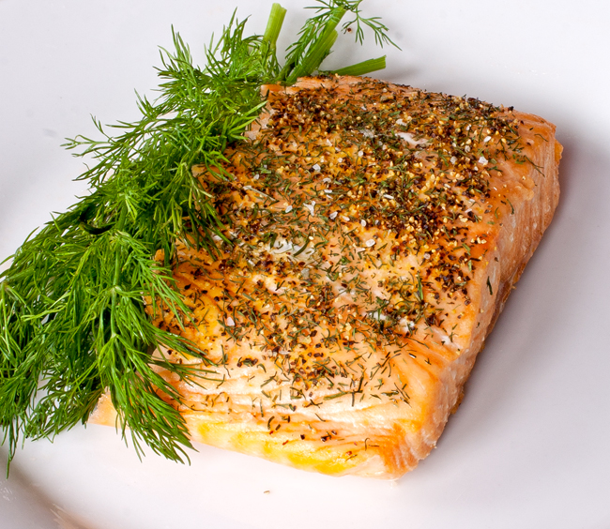

Figure for Oven Baked Salmon

Inside western cuisine, there are several parts such as:

* + 1. Central European cuisine:
* Austrian cuisine:
* German cuisine:
* Bulgarian cuisine:
* Czech cuisine:
* Hungarian cuisine:
* Polish cuisine:
* Romanian cuisine:
  + 1. Eastern European cuisine:
* Russian cuisine:

As a largest country in the world,

* Ukrainian cuisine:
* Caucasian cuisine:
* Azerbaijani cuisine:
* Georgian cuisine:
  + 1. Northern European cuisine:

Cuisines from the Isles of the North Atlantic (IONA):

* British cuisine:
* English cuisine:
* Scottish cuisine:
* Welsh cuisine:
* Cuisine of Saint Helena:
* Anglo-Indian cuisine:
* Balti cuisine:
* Wine from the United Kingdom:
* Scandinavian cuisine:
* Finnish cuisine:
* Icelandic cuisine:
  + 1. Southern European cuisine:
* Mediterranean cuisine
* Cuisine of Balkans:
* Greek cuisine:
* Cuisines of the Italian Peninsula:
* Roman cuisine
* Lombardy cuisine
* Neapolitan cuisine
* Venetian cuisine
* Sicilian cuisine
* Marche cuisine
* Spanish cuisine:
* [Andalusian cuisine](https://en.wikipedia.org/wiki/Andalusian_cuisine)
* [Asturian cuisine](https://en.wikipedia.org/wiki/Asturian_cuisine)
* [Aragonese cuisine](https://en.wikipedia.org/wiki/Aragonese_cuisine)
* [Balearic cuisine](https://en.wikipedia.org/wiki/Balearic_cuisine)
* [Basque cuisine](https://en.wikipedia.org/wiki/Basque_cuisine)
* [Canarian cuisine](https://en.wikipedia.org/wiki/Canarian_cuisine)
* [Cantabrian cuisine](https://en.wikipedia.org/wiki/Cantabrian_cuisine)
* [Castilian-Leonese cuisine](https://en.wikipedia.org/wiki/Castilian-Leonese_cuisine)
* [Castilian-Manchego cuisine](https://en.wikipedia.org/wiki/Castilian-Manchego_cuisine)
* [Cuisine of the Community of Madrid](https://en.wikipedia.org/wiki/Cuisine_of_the_Community_of_Madrid)
* [Catalan cuisine](https://en.wikipedia.org/wiki/Catalan_cuisine) (includes [Andorran cuisine](https://en.wikipedia.org/wiki/Andorran_cuisine))
  + 1. Western European cuisine:
* French cuisine:
* Belgian cuisine:
* Luxembourgian cuisine:
* Swiss cuisine:

**Conclusion**

From International Cuisine, we learn about the brief history of different cuisine from different country and region. We also known how the culture did affection to local food and created great recipe and dishes. It bring economic benefit and known as publicity. Like people know an Indian food is always spicy, the question is why it is so spicy? First reason is because the spicy mean the food is safety from food borne illness, spices can keep the food longer and avoid from microbes and bacteria. Second reason is the climate, in Indian, hot climate make people like heavy food than light food. Third reason is, the spicy food became a culture, people eat spicy food when they are young and it became a kind of habit, just like Chinese usually eat rice and French eat baguette as their breakfast.

**References**

MEHROTRA, P. K. (2016, Mar 12th). *indiatodayin*. Retrieved Aug 22th, 2017, http://indiatoday.intoday.in/: http://indiatoday.intoday.in/story/arunchal-pradesh-rock-and-rice-beer-in-ziro-valley-tawang-monastery-apatani/1/617568.html

MEHROTRA, P. K. (2012, Sept 22th). *MailOnline*. Retrieved Aug 23th, 2017, http://www.dailymail.co.uk/home/index.html: http://www.dailymail.co.uk/indiahome/indianews/article-2207116/Rice-beer-rat-rolling-hills-Nothing-like-music-festival-distant-Arunachal-Pradesh.html

Mishra, A. K. (2014, Jul 31th). *SlideShare*. Retrieved Aug 14th, 2017,

https://www.slideshare.net/: https://www.slideshare.net/atulji7777/international-cuisines

Sarkar, P. V. (2017, Apr 16th). *thespruce*. Retrieved Aug 11th, 2017,

https://www.thespruce.com/: https://www.thespruce.com/cuisine-of-north-india-1957883

Sarkar, P. V. (2017, Jan 27th). *thespruce*. Retrieved Aug 12th, 2017,

https://www.thespruce.com/: https://www.thespruce.com/mughlai-biryani-recipe-1957724

Unknown. (2017, Jul 13th). *FOOD NDTV*. Retrieved Aug 20th, 2017,

http://food.ndtv.com/: http://food.ndtv.com/food-drinks/cuisine-of-arunachal-foodies-trail-in-itanagar-1232109

Unknown. (2015, Nov 11th). *Style by Joules*. Retrieved Aug 10th, 2017,

http://stylebyjoules.com/: http://stylebyjoules.com/health-wellness/recipes/oven-baked-salmon/

**Appendix**

The End